Homework 4 Brandon Gage

Joanna Warrick

To run our program, please run the “HW4_JoannaWarrick_BrandonGage” class 4 times. In each console, the program will prompt you to enter an id. Please label each node as 0, 1, 2, or 3. Within each instance of the main class, our program will create two threads to both broadcast its local topology to the other nodes in the network and listen for incoming link state packets. Each node’s local topology is stored in the “input<nodeID>.txt” files as an edge list. As soon as a node has a complete network topology, it runs Dijkstra’s algorithm to generate the minimum distance from the current node to its neighbors as well as prints a forwarding table based on the initial node. To run a different test case, please change the edge lists in the input<nodeID>.txt files.

Example 1

Input graph visualization:

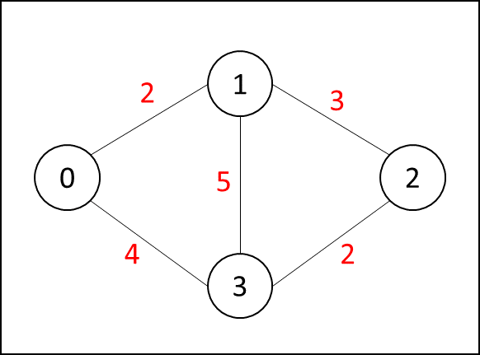

Node 0 output:

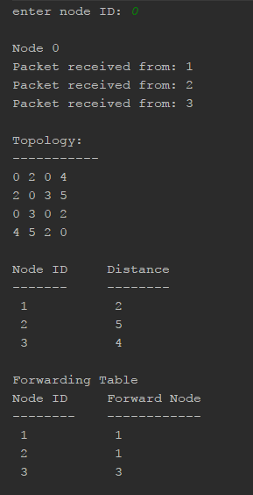 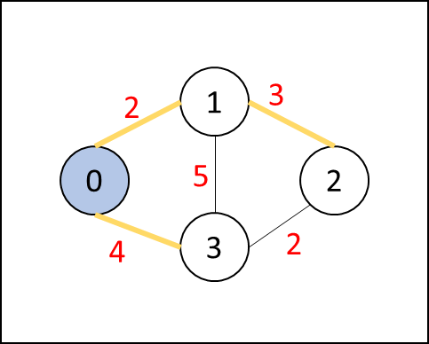

Output visualization

Example 2

Input graph visualization:

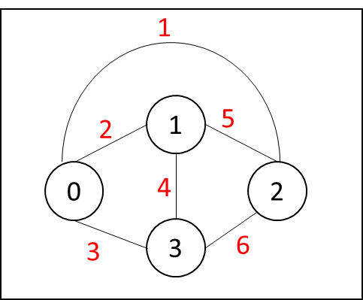

Node 0 output:

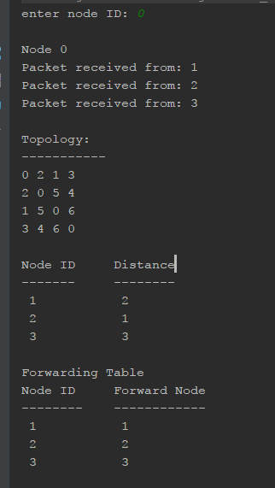 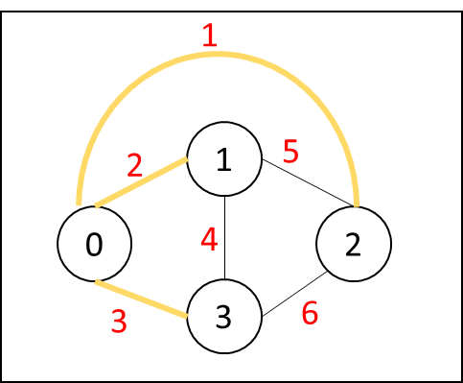

Output visualization

Example 2, Node 2 output

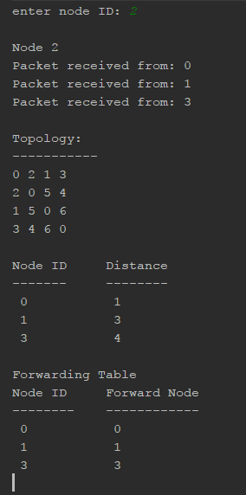 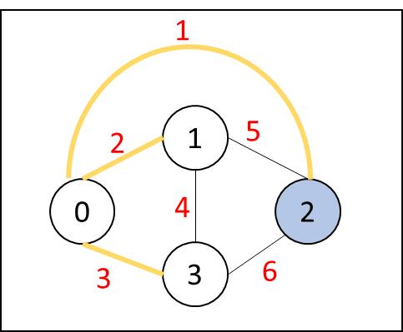

Output visualization